**II.COUNTRIES & FLAGS & CROWNS**

**országok,zászlók,koronák**

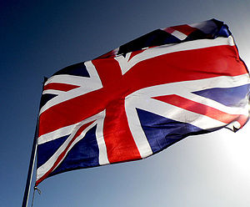**Click on the link and find the information!**

**klikkelj a weboldalra és keresd meg**

[**http://www.woodlands-junior.kent.sch.uk/geography/unionjack.html**](http://www.woodlands-junior.kent.sch.uk/geography/unionjack.html)

**Write the name of the country next to its flag!**

**írd az országok nevét a zászló mellé**

The Union Flag, popularly known as the *[Union Jack](http://www.woodlands-junior.kent.sch.uk/geography/unionjack.html#jack), is the national flag of the [United Kingdom](http://www.woodlands-junior.kent.sch.uk/customs/questions/britain/uk.htm). It is the British flag. It is called the Union Flag because it symbolises the administrative union of the countries of the United Kingdom.Scotland is represented by the flag of St. Andrew. After [Queen Elizabeth I](http://www.woodlands-junior.kent.sch.uk/customs/questions/kings.htm) of England died in 1603, King James VI of Scotland inherited the English throne and became [King James I](http://www.woodlands-junior.kent.sch.uk/customs/questions/kings.htm) of England. It was a Union of the Crowns, but not yet of the nations. Each country still kept their own parliament.A compromise was the answer and it led to the creation of the first Union Flag. On 12 April **1606**, the National Flags of Scotland and England were united for use at sea, thus making the first Union 'Jack'. Ireland is represented by the cross of St. Patrick. The cross St Patrick was combined with the Union Flag of St George and St Andrew, to create the **Union Flag** that has been flown ever since.

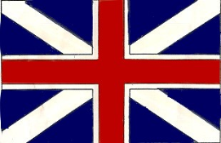1.

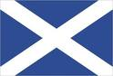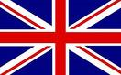**2.**

5.

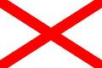

3.

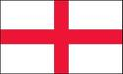

4.